**CS628 Full-Stack Development II – Backend**

**HOS01D Client-Side vs. Server-Side JavaScript**

July 16, 2020

12/29/2020 Updated by Min

School of Technology & Computing (STC)

City University of Seattle (CityU)

**Before You Start**

* The directory path shown in screenshots may be different from yours.
* This HOS does not explain all steps in detail**.** If you are not sure what to do:
  1. Consult the resources listed below.
  2. If you cannot solve the problem after a few tries, ask a TA for help.

**Resources**

* JS Tutorial, <https://www.w3schools.com/js/default.asp>
* JavaScript Introduction, <https://www.w3schools.com/js/js_intro.asp>
* JavaScript Functions, <https://www.w3schools.com/js/js_functions.asp>

**Learning Outcomes**

Students will be able to:

* Understand how client-side and server-side JavaScript programs are executed differently.
* Analyze a client-side JavaScript application requiring Browser, HTML, and DOM.
* Analyze a server-side JavaScript application requiring Node.

**Activities**

* Preparing for a MEAN project environment
* **Experiencing a client-side JavaScript**
* **Experiencing a server-side JavaScript**
* Pushing your work to GitHub

**Preparing for a MEAN project environment**

1. Create the “module01a” folder under your repo:  
   >>>mkdir module01a  
   you will see like that:



1. Open the “module01a” folder in the VSCode.  
   Close the “Welcome” window.  
   Open the terminal (Ctrl+`).

**Experiencing a client-side JavaScript**

1. Create a “client-side” under the “module01a” directory and move to the directory.  
   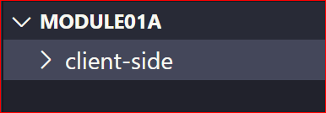
2. Create a “clientSide.html” file under the “client-side” directory.
3. Create a simple HTML scaffold.  
   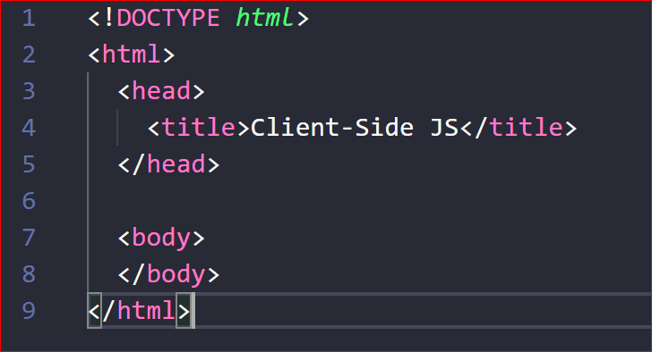
4. By right clicking the file, select “Reveal in File Explorer” menu.
5. Then, open the file in your browser. Check the title of the file.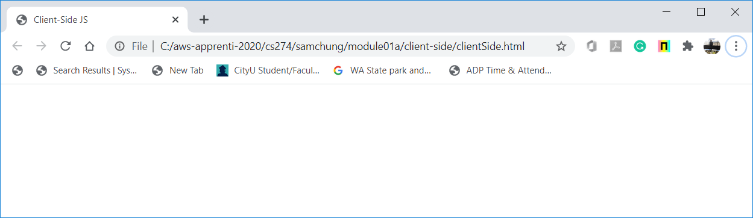
6. Before writing your code, visit the following JS tutorial and study them.  
   1. JS Tutorial, <https://www.w3schools.com/js/default.asp>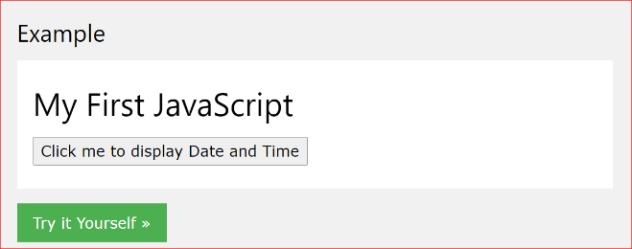
   2. JavaScript Introduction, <https://www.w3schools.com/js/js_intro.asp>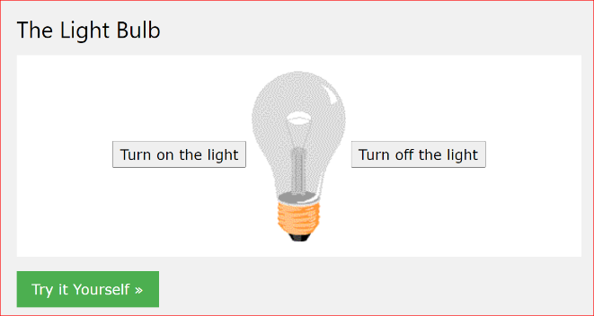
   3. JavaScript Functions, <https://www.w3schools.com/js/js_functions.asp>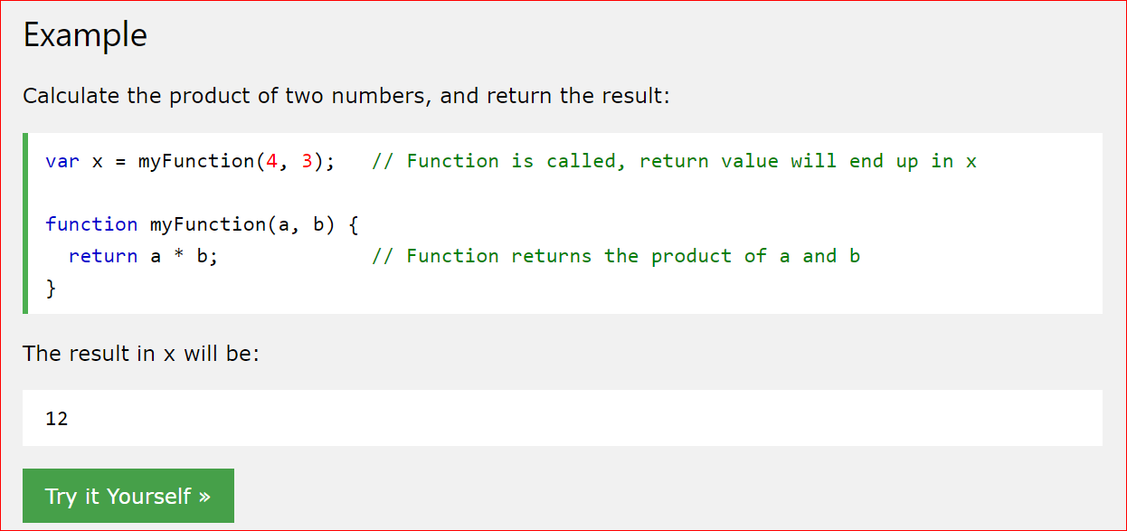
7. Add to the file a client-side JavaScript application that displays the current data and time.  
   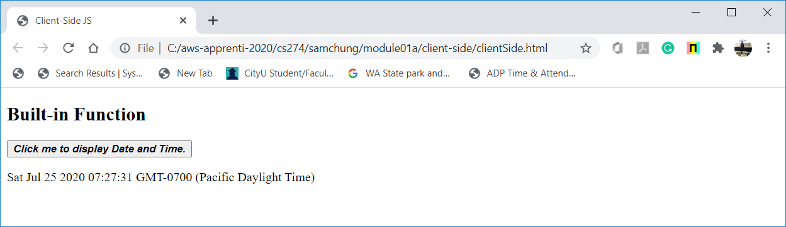
8. Add to the file a client-side JavaScript application that calculates the product of two given numbers.  
   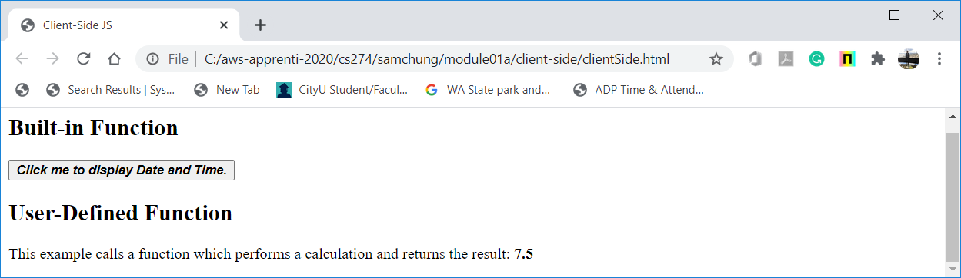
9. By right clicking the file, select “Inspect” menu.  
   Check each HTML tag.

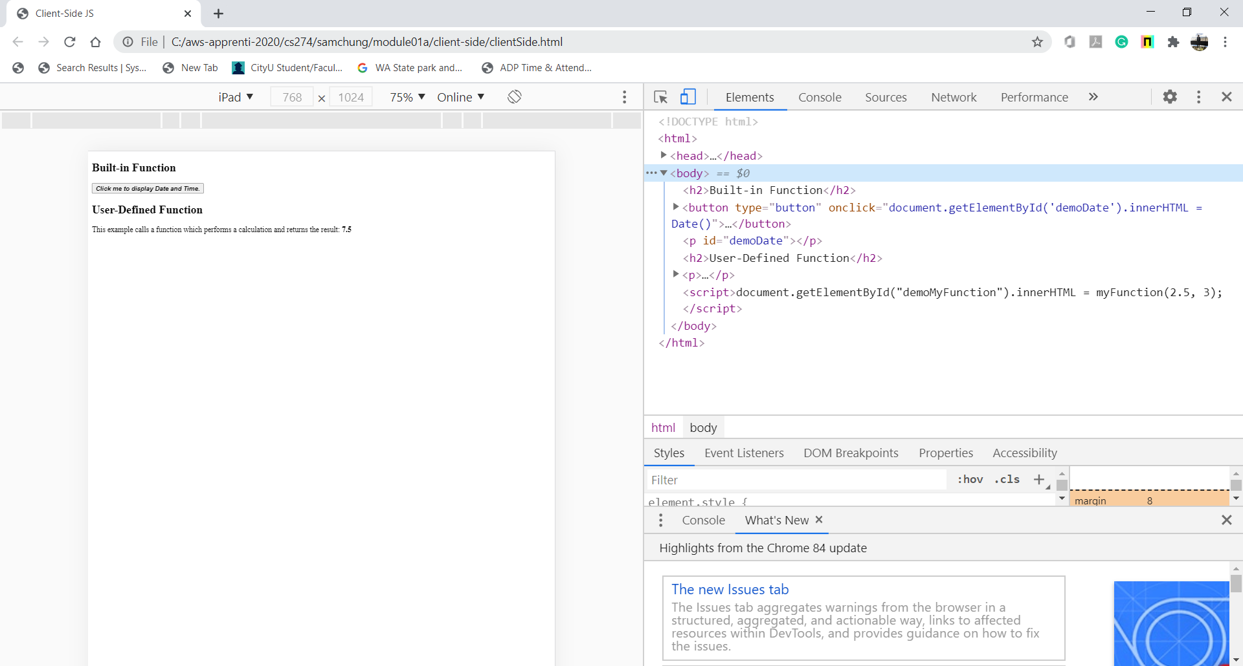

**Experiencing a server-side JavaScript**

1. Create a “server-side” under the “module01a” directory and move to the directory.  
   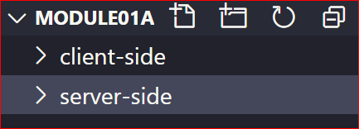
2. Create a “serverSide.js” file under the “server-side” directory.
3. Create a simple JavaScript scaffold.  
   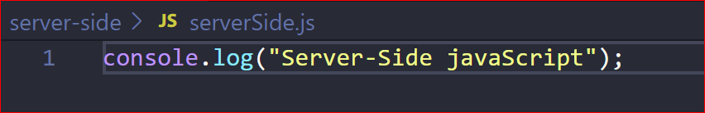
4. Execute it with node.  
   >>>node serverSide.js  
   
5. Add to the file a server-side JavaScript application that displays the current data and time.  
   Execute it.  
   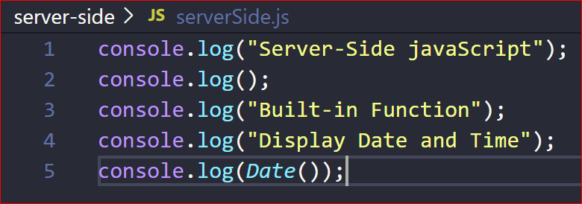  
     
   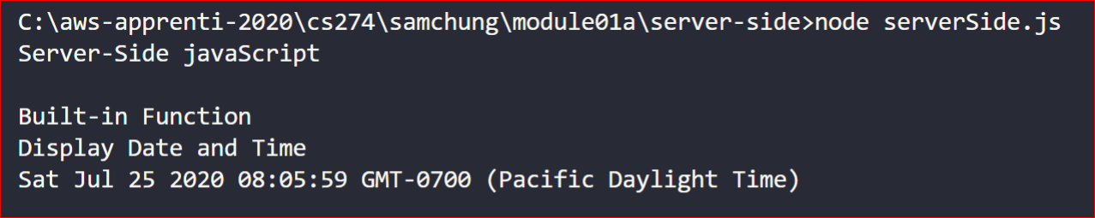
6. Add to the file a server-side JavaScript application that calculates the product of two given numbers.  
   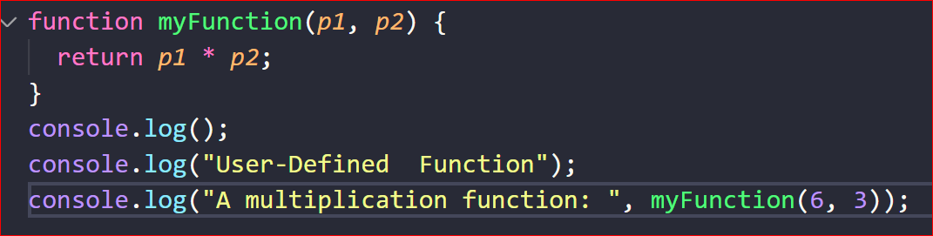  
     
   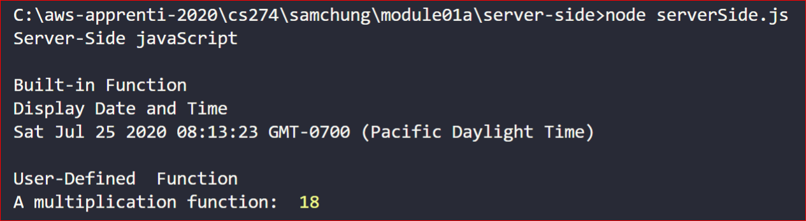

**Pushing your work to GitHub**

Run the following commands to push your work to the GitHub repository:

Open the terminal from the VSCode by hitting the control + ~ key and type the following command:

>>> git add .

>>> git commit -m “Submission for Module 1 --yourname”

>>> git push origin master

If you cannot remember your branch name, run the command “git status” to check.